Random Sampling
Inbal Lorena Eshel
28/09/25

Perform Random stratified sampling

1st random sampling

Test data as a result of random sampling
2A, 2E, 2I, 2J, 2S, 2AC, 2AE, 2AH, 2AO, 2AR, 2AU, 2AX
formula | McFadden R2 | Train Accuracy | Test Accuracy
class ~ X.2.3. + Dist.1..2. + NPA_3 + diff.1.2 | 0.740 | 88.37 | 66.67
class ~ X.2.3. + NPA_3 + diff.1.2 + L | 0.740 | 88.37 | 66.67
class ~ X.2.3. + NPA_2 + NPA_3 + diff.1.2 | 0.737 | 90.70 | 66.67
class ~ X.2.3. + NPA_3 + diff.1.2 + loc.B5 | 0.735 | 90.70 | 66.67
class ~ X.2.3. + Dist.2..3. + NPA_1 + diff.2.3 | 0.731 | 90.70 | 66.67
class ~ X.2.3. + NPA_1 + NPA_3 + B5 | 0.730 | 86.05 | 75.00
class ~ X.2.3. + dip_z + NPA_1 + NPA_3 | 0.729 | 88.37 | 75.00
class ~ X.2.3. + Dist.2..7. + diff.1.2 + diff.2.3 | 0.728 | 90.70 | 58.33
class ~ X.2.3. + NPA_1 + NPA_3 + diff.1.2 | 0.728 | 88.37 | 66.67
class ~ X.2.3. + NPA_1 + NPA_3 + L | 0.725 | 86.05 | 66.67

2nd random sampling

Test data as a result of random sampling
2B, 2S, 2T, 2U, 2V, 2AA, 2AD, 2AF, 2AM, 2AN, 2AZ, 2BC
formula | McFadden R2 | Train Accuracy | Test Accuracy
class ~ X.2.3. + dip_x + dip_y + NPA_1 | 0.603 | 81.40 | 75.00
class ~ X.2.3. + dip_y + Dist.2..7. + diff.1.2 | 0.597 | 81.40 | 66.67
class ~ Total + NPA_7 + B5 + loc.B5 | 0.597 | 86.05 | 75.00
class ~ X.2.3. + dip_y + Dist.2..7. + B5 | 0.590 | 83.72 | 66.67
class ~ X.2.3. + dip_y + NPA_1 + NPA_3 | 0.585 | 81.40 | 91.67
class ~ Total + NPA_3 + B5 + loc.B5 | 0.584 | 86.05 | 83.33
class ~ Total + diff.2.7 + B5 + loc.B5 | 0.584 | 83.72 | 83.33
class ~ X.2.3. + dip_x + dip_y + Dist.2..7. | 0.583 | 81.40 | 66.67
class ~ X.2.3. + dip_y + NPA_3 + diff.1.2 | 0.583 | 79.07 | 83.33
class ~ X.2.3. + dip_y + Dist.2..7. + NPA_1 | 0.581 | 79.07 | 66.67

3rd random sampling

Test data as a result of random sampling
2J, 2N, 2O, 2T, 2V, 2AC, 2AF, 2AL, 2AP, 2AQ, 2AU, 2BC
formula | McFadden R2 | Train Accuracy | Test Accuracy
class ~ X.2.3. + dip_y + NPA_3 + diff.1.2 | 0.760 | 90.70 | 83.33
class ~ dip_y + Dist.2..7. + NPA_3 + diff.1.2 | 0.750 | 88.37 | 83.33
class ~ X.2.7. + dip_y + NPA_1 + NPA_3 | 0.732 | 90.70 | 75.00
class ~ X.2.3. + dip_y + NPA_1 + NPA_3 | 0.720 | 88.37 | 83.33
class ~ X.2.3. + dip_y + diff.1.2 + diff.2.3 | 0.718 | 83.72 | 83.33
class ~ X.2.3. + dip_y + Dist.2..7. + diff.1.2 | 0.715 | 86.05 | 58.33
class ~ X.2.3. + NPA_7 + diff.1.2 + diff.2.3 | 0.714 | 88.37 | 83.33
class ~ X.2.3. + NPA_3 + diff.1.2 + L | 0.710 | 83.72 | 75.00
class ~ X.2.3. + NPA_1 + NPA_7 + diff.2.3 | 0.707 | 83.72 | 83.33
class ~ X.2.3. + Dist.2..7. + NPA_3 + diff.1.2 | 0.705 | 83.72 | 75.00

4th random sampling

Test data as a result of random sampling
2D, 2N, 2R, 2S, 2V, 2Z, 2AB, 2AF, 2AH, 2AI, 2AT, 2BA
formula | McFadden R2 | Train Accuracy | Test Accuracy
class ~ X.2.3. + dip_y + NPA_1 + NPA_3 | 0.650 | 83.72 | 83.33
class ~ X.2.3. + dip_y + NPA_1 + diff.2.3 | 0.645 | 83.72 | 83.33
class ~ X.2.3. + dip_y + Dist.2..7. + diff.1.2 | 0.634 | 83.72 | 83.33
class ~ dip_y + NPA_1 + NPA_3 + NPA_7 | 0.631 | 86.05 | 83.33
class ~ dip_y + NPA_3 + diff.1.2 + diff.2.7 | 0.630 | 86.05 | 83.33
class ~ X.2.7. + dip_y + NPA_1 + NPA_3 | 0.628 | 86.05 | 75.00
class ~ X.2.3. + dip_y + NPA_3 + diff.1.2 | 0.626 | 83.72 | 75.00
class ~ X.2.3. + dip_y + Dist.2..3. + NPA_1 | 0.625 | 83.72 | 75.00
class ~ dip_y + NPA_1 + NPA_2 + NPA_3 | 0.625 | 86.05 | 83.33
class ~ dip_y + NPA_1 + NPA_3 + diff.1.2 | 0.625 | 86.05 | 83.33

5th random sampling

Test data as a result of random sampling
2E, 2F, 2K, 2O, 2S, 2AA, 2AC, 2AJ, 2AK, 2AN, 2AW, 2BA
formula | McFadden R2 | Train Accuracy | Test Accuracy
class ~ Total + NPA_1 + B5 + loc.B5 | 0.697 | 86.05 | 75.00
class ~ Total + diff.1.2 + B5 + loc.B5 | 0.692 | 86.05 | 75.00
class ~ Total + NPA_1 + B1 + loc.B5 | 0.667 | 83.72 | 66.67
class ~ dip_x + dip_y + NPA_1 + loc.B5 | 0.664 | 83.72 | 83.33
class ~ Total + NPA_1 + L + loc.B5 | 0.663 | 86.05 | 66.67
class ~ Total + diff.1.2 + B1 + loc.B5 | 0.663 | 83.72 | 66.67
class ~ dip_x + dip_y + diff.1.2 + loc.B5 | 0.662 | 83.72 | 83.33
class ~ Total + diff.1.2 + L + loc.B5 | 0.657 | 86.05 | 66.67
class ~ Total + diff.1.2 + diff.2.3 + loc.B5 | 0.656 | 88.37 | 75.00
class ~ dip_y + Total + NPA_1 + loc.B5 | 0.654 | 83.72 | 66.67

6th random sampling

Test data as a result of random sampling
2D, 2N, 2P, 2U, 2V, 2W, 2AC, 2AK, 2AL, 2AQ, 2AZ, 2BC
formula | McFadden R2 | Train Accuracy | Test Accuracy
class ~ X.2.3. + dip_y + NPA_3 + diff.1.2 | 0.575 | 86.05 | 91.67
class ~ dip_y + NPA_3 + diff.1.2 + L | 0.566 | 76.74 | 83.33
class ~ dip_z + Total + NPA_7 + loc.B5 | 0.560 | 83.72 | 75.00
class ~ dip_z + Total + diff.2.7 + loc.B5 | 0.559 | 83.72 | 75.00
class ~ X.2.3. + dip_y + NPA_1 + B1 | 0.557 | 83.72 | 91.67
class ~ dip_y + NPA_1 + NPA_3 + L | 0.557 | 81.40 | 83.33
class ~ Total + diff.1.2 + diff.2.3 + loc.B5 | 0.555 | 83.72 | 91.67
class ~ X.2.7. + dip_y + NPA_1 + NPA_3 | 0.550 | 81.40 | 91.67
class ~ dip_x + dip_y + diff.1.2 + loc.B5 | 0.550 | 81.40 | 91.67
class ~ dip_y + NPA_1 + NPA_2 + NPA_3 | 0.549 | 86.05 | 83.33

7th random sampling

Test data as a result of random sampling
2B, 2H, 2R, 2T, 2V, 2X, 2AD, 2AE, 2AF, 2AI, 2AY, 2AZ
formula | McFadden R2 | Train Accuracy | Test Accuracy
class ~ X.2.3. + dip_y + Dist.2..7. + B5 | 0.651 | 86.05 | 58.33
class ~ dip_y + NPA_2 + NPA_3 + B5 | 0.643 | 88.37 | 58.33
class ~ dip_y + NPA_3 + diff.2.3 + B5 | 0.641 | 86.05 | 58.33
class ~ X.2.3. + dip_y + NPA_1 + NPA_3 | 0.636 | 83.72 | 91.67
class ~ X.2.3. + dip_y + NPA_3 + diff.1.2 | 0.636 | 83.72 | 91.67
class ~ dip_y + NPA_2 + diff.2.3 + B5 | 0.633 | 86.05 | 58.33
class ~ X.2.3. + dip_y + Dist.2..7. + NPA_1 | 0.628 | 81.40 | 66.67
class ~ X.2.3. + dip_y + diff.1.2 + diff.2.3 | 0.628 | 83.72 | 91.67
class ~ dip_y + NPA_3 + diff.1.2 + diff.2.7 | 0.627 | 83.72 | 83.33
class ~ dip_y + NPA_3 + diff.1.2 + B5 | 0.625 | 90.70 | 83.33

8th random sampling

Test data as a result of random sampling
2A, 2B, 2E, 2L, 2O, 2Z, 2AB, 2AE, 2AH, 2AJ, 2AX, 2BC
formula | McFadden R2 | Train Accuracy | Test Accuracy
class ~ dip_y + NPA_3 + diff.1.2 + L | 0.631 | 88.37 | 75.00
class ~ Total + NPA_1 + NPA_3 + loc.B5 | 0.611 | 88.37 | 66.67
class ~ X.2.3. + dip_y + NPA_3 + diff.1.2 | 0.602 | 86.05 | 75.00
class ~ Total + NPA_3 + diff.1.2 + loc.B5 | 0.602 | 88.37 | 75.00
class ~ Total + NPA_1 + diff.2.3 + loc.B5 | 0.599 | 88.37 | 75.00
class ~ Total + diff.1.2 + diff.2.3 + loc.B5 | 0.598 | 88.37 | 83.33
class ~ dip_y + NPA_3 + NPA_7 + diff.1.2 | 0.596 | 88.37 | 75.00
class ~ X.2.3. + dip_y + NPA_1 + NPA_3 | 0.593 | 88.37 | 75.00
class ~ dip_y + NPA_3 + diff.1.2 + diff.2.7 | 0.593 | 88.37 | 75.00
class ~ X.2.7. + dip_y + NPA_3 + diff.1.2 | 0.591 | 86.05 | 75.00

9th random sampling

Test data as a result of random sampling
2B, 2D, 2L, 2U, 2V, 2Z, 2AD, 2AF, 2AM, 2AN, 2BB, 2BC
formula | McFadden R2 | Train Accuracy | Test Accuracy
class ~ X.2.3. + dip_y + NPA_1 + NPA_3 | 0.587 | 81.40 | 91.67
class ~ X.2.3. + dip_y + NPA_3 + diff.1.2 | 0.583 | 81.40 | 91.67
class ~ X.2.7. + dip_y + NPA_1 + NPA_3 | 0.577 | 81.40 | 83.33
class ~ dip_y + dip_z + diff.2.3 + loc.B5 | 0.577 | 79.07 | 66.67
class ~ dip_y + dip_z + NPA_3 + loc.B5 | 0.571 | 79.07 | 66.67
class ~ dip_y + NPA_1 + NPA_3 + diff.2.7 | 0.567 | 81.40 | 83.33
class ~ dip_y + Dist.2..7. + NPA_1 + NPA_3 | 0.565 | 83.72 | 91.67
class ~ dip_y + NPA_3 + diff.1.2 + loc.B5 | 0.564 | 79.07 | 91.67
class ~ Total + Dist.1..2. + NPA_2 + NPA_3 | 0.563 | 86.05 | 75.00
class ~ dip_y + NPA_1 + NPA_3 + loc.B5 | 0.560 | 79.07 | 91.67

10th random sampling

Test data as a result of random sampling
2A, 2C, 2I, 2O, 2R, 2AD, 2AH, 2AJ, 2AK, 2AO, 2AV, 2AY
formula | McFadden R2 | Train Accuracy | Test Accuracy
class ~ X.2.3. + dip_y + NPA_1 + NPA_3 | 0.680 | 88.37 | 75.00
class ~ X.2.3. + dip_y + NPA_3 + diff.1.2 | 0.680 | 88.37 | 75.00
class ~ dip_y + NPA_1 + NPA_3 + NPA_7 | 0.671 | 88.37 | 66.67
class ~ dip_y + NPA_3 + NPA_7 + diff.1.2 | 0.671 | 88.37 | 66.67
class ~ dip_y + NPA_2 + NPA_3 + diff.1.2 | 0.670 | 88.37 | 66.67
class ~ dip_y + Dist.2..7. + NPA_1 + NPA_3 | 0.665 | 88.37 | 66.67
class ~ dip_y + NPA_3 + diff.1.2 + diff.2.7 | 0.665 | 88.37 | 66.67
class ~ dip_y + NPA_1 + NPA_3 + diff.2.3 | 0.662 | 88.37 | 66.67
class ~ dip_y + NPA_3 + diff.1.2 + L | 0.660 | 88.37 | 66.67
class ~ dip_y + NPA_1 + NPA_2 + NPA_3 | 0.659 | 88.37 | 58.33

Summary of most appearing models:
Summary of Model Performance
Formula | Count | Average Test Accuracy | Average Train-Test Gap | Average McFadden R² | McFadden R² SD
class ~ X.2.3. + dip_y + NPA_3 + diff.1.2 | 8 | 83.33 | 1.55 | 0.63 | 0.06
class ~ X.2.3. + dip_y + NPA_1 + NPA_3 | 7 | 84.52 | 0.53 | 0.64 | 0.05
class ~ dip_y + NPA_3 + diff.1.2 + diff.2.7 | 4 | 77.08 | 9.55 | 0.63 | 0.03
class ~ X.2.7. + dip_y + NPA_1 + NPA_3 | 4 | 81.25 | 3.64 | 0.62 | 0.08
class ~ X.2.3. + dip_y + Dist.2..7. + diff.1.2 | 3 | 69.44 | 14.28 | 0.65 | 0.06
class ~ dip_y + NPA_3 + diff.1.2 + L | 3 | 75.00 | 9.49 | 0.62 | 0.05
class ~ dip_y + NPA_1 + NPA_2 + NPA_3 | 3 | 75.00 | 11.83 | 0.61 | 0.06
class ~ Total + diff.1.2 + diff.2.3 + loc.B5 | 3 | 83.33 | 3.49 | 0.60 | 0.05
class ~ X.2.3. + NPA_3 + diff.1.2 + L | 2 | 70.84 | 15.21 | 0.72 | 0.02
class ~ X.2.3. + dip_y + diff.1.2 + diff.2.3 | 2 | 87.50 | 3.78 | 0.67 | 0.06
class ~ dip_y + NPA_1 + NPA_3 + NPA_7 | 2 | 75.00 | 12.21 | 0.65 | 0.03
class ~ dip_y + NPA_3 + NPA_7 + diff.1.2 | 2 | 70.84 | 17.54 | 0.63 | 0.05
class ~ X.2.3. + dip_y + Dist.2..7. + B5 | 2 | 62.50 | 22.38 | 0.62 | 0.04
class ~ dip_y + Dist.2..7. + NPA_1 + NPA_3 | 2 | 79.17 | 6.88 | 0.62 | 0.07
class ~ dip_x + dip_y + diff.1.2 + loc.B5 | 2 | 87.50 | 4.94 | 0.61 | 0.08

Chosen model with external validation and prediction

Test data as a result of random sampling
2B, 2D, 2K, 2S, 2T, 2AF, 2AK, 2AL, 2AM, 2AN, 2AU, 2AX
5-fold cross-validation
[1] 80.94
Leave one out cross-validation
[1] 83.72

Train
Table:
Full Model Stats - Overall Accuracy and Pseudo-R2
accuracy_formatted | McFadden_R2
83.72% | 0.602
Model Coefficients
 | x
X.2.3. | -0.0619221
dip_y | -1.5312102
NPA_3 | -121.5570063
diff.1.2 | -25.5299802
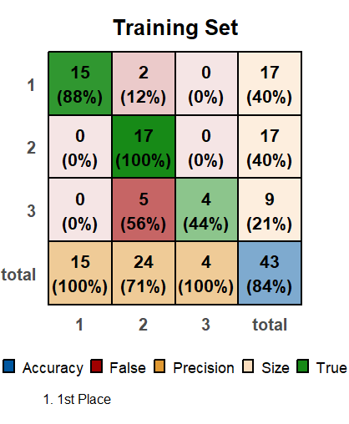
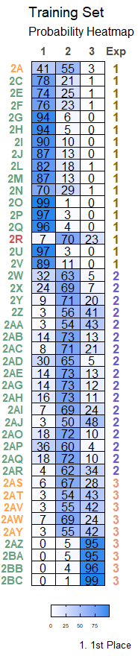

Test
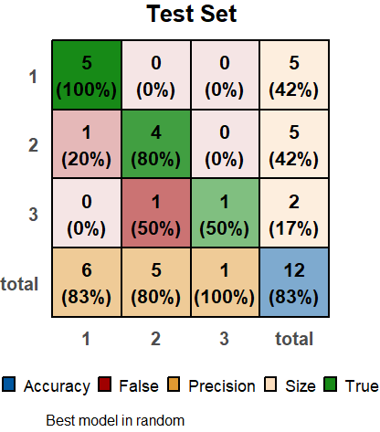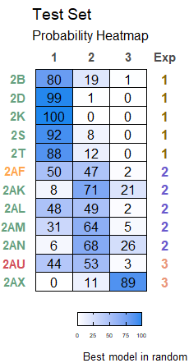
External validation
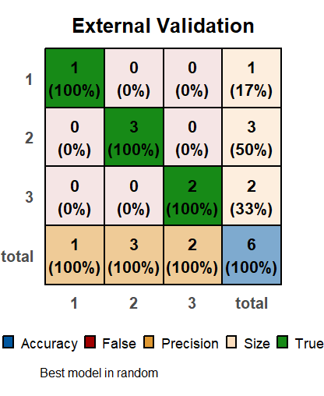
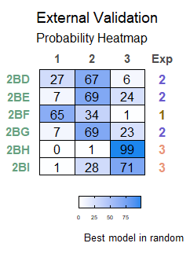
Predictions
 | 1 | 2 | 3 | predicted_class
2BM | 99.8324226 | 0.1636025 | 0.0039749 | 1
2BO | 0.0008869 | 0.0365535 | 99.9625595 | 3
2BS | 99.9913641 | 0.0084314 | 0.0002045 | 1
2BW | 4.3729029 | 61.5095879 | 34.1175092 | 2

